Hands-on :
Spring Core and Maven

Exercise 1:
Configuring a Basic Spring Application
File name: pom.xml
<project xmlns="http://maven.apache.org/POM/4.0.0"
xmlns:xsi="http://www.w3.org/2001/XMLSchema-instance"
xsi:schemaLocation="http://maven.apache.org/POM/4.0.0
http://maven.apache.org/xsd/maven-4.0.0.xsd">

<modelVersion>4.0.0</modelVersion>

<groupId>com.library</groupId>
<artifactId>LibraryManagement</artifactId>
<version>0.0.1-SNAPSHOT</version>
<packaging>jar</packaging>

<name>LibraryManagement</name>
<url>http://maven.apache.org</url>

<properties>
<project.build.sourceEncoding>UTF-8</project.build.sourceEncoding>
<maven.compiler.source>1.8</maven.compiler.source>
<maven.compiler.target>1.8</maven.compiler.target>
</properties>

<dependencies>

<dependency>
<groupId>org.springframework</groupId>
<artifactId>spring-context</artifactId>
<version>5.3.39</version>
</dependency>

<dependency>
<groupId>junit</groupId>
<artifactId>junit</artifactId>
<version>3.8.1</version>
<scope>test</scope>
</dependency>

</dependencies>

</project>

Filename: applicationContext.xml
<?xml version="1.0" encoding="UTF-8"?>

<beans xmlns="http://www.springframework.org/schema/beans"
xmlns:xsi="http://www.w3.org/2001/XMLSchema-instance"
xsi:schemaLocation="
http://www.springframework.org/schema/beans
http://www.springframework.org/schema/beans/spring-beans.xsd">

<bean id="bookRepository"
class="com.library.repository.BookRepository"/>

<bean id="bookService"
class="com.library.service.BookService">
<property name="bookRepository" ref="bookRepository"/>
</bean>

</beans>

Filename: BookRepository.java
package com.library.repository;

public class BookRepository {

public void displayRepository() {
System.out.println("BookRepository bean created successfully.");
}
}

Filename: BookService.java
package com.library.service;

import com.library.repository.BookRepository;

public class BookService {

private BookRepository bookRepository;

public void setBookRepository(BookRepository bookRepository) {
this.bookRepository = bookRepository;
}

public void displayService() {
System.out.println("BookService bean created successfully.");
bookRepository.displayRepository();
}
}

Filename: LibraryApplication.java
package com.library.LibraryManagement;

import org.springframework.context.ApplicationContext;
import org.springframework.context.support.ClassPathXmlApplicationContext;
import com.library.service.BookService;

public class LibraryApplication {

public static void main(String[] args) {

ApplicationContext context =
new ClassPathXmlApplicationContext("applicationContext.xml");

BookService service = (BookService) context.getBean("bookService");

service.displayService();
}
}
Output :
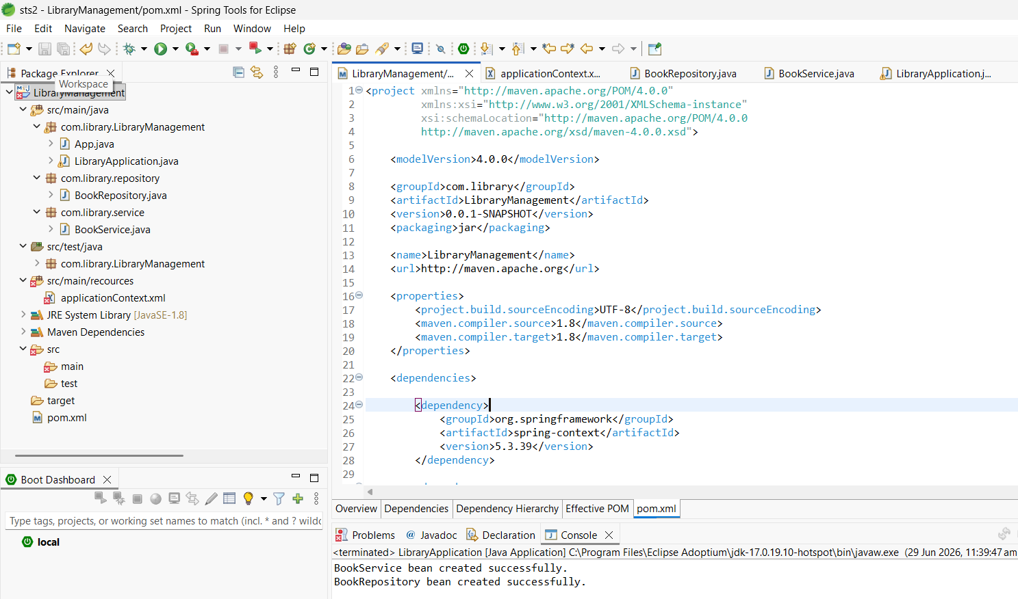

Exercise 2:
Implementing Dependency Injection
File name: applicationContext.xml
<?xml version="1.0" encoding="UTF-8"?>

<beans xmlns="http://www.springframework.org/schema/beans"
xmlns:xsi="http://www.w3.org/2001/XMLSchema-instance"
xsi:schemaLocation="
http://www.springframework.org/schema/beans
http://www.springframework.org/schema/beans/spring-beans.xsd">

<bean id="bookRepository"
class="com.library.repository.BookRepository"/>

<bean id="bookService"
class="com.library.service.BookService">
<property name="bookRepository" ref="bookRepository"/>
</bean>

</beans>

Filename: BookRepository.java
package com.library.repository;

public class BookRepository {

public void displayRepository() {
System.out.println("BookRepository bean created successfully.");
}
}

Filename: BookService.java
package com.library.service;

import com.library.repository.BookRepository;

public class BookService {

private BookRepository bookRepository;

public void setBookRepository(BookRepository bookRepository) {
this.bookRepository = bookRepository;
}

public void displayService() {
System.out.println("BookService bean created successfully.");
bookRepository.displayRepository();
}
}

Filename: LibraryApplication.java
package com.library.LibraryManagement;

import org.springframework.context.ApplicationContext;
import org.springframework.context.support.ClassPathXmlApplicationContext;

import com.library.service.BookService;

public class LibraryApplication {

public static void main(String[] args) {

ApplicationContext context = new ClassPathXmlApplicationContext("applicationContext.xml");
BookService service = (BookService) context.getBean("bookService");

service.displayService();
}
}

Output :
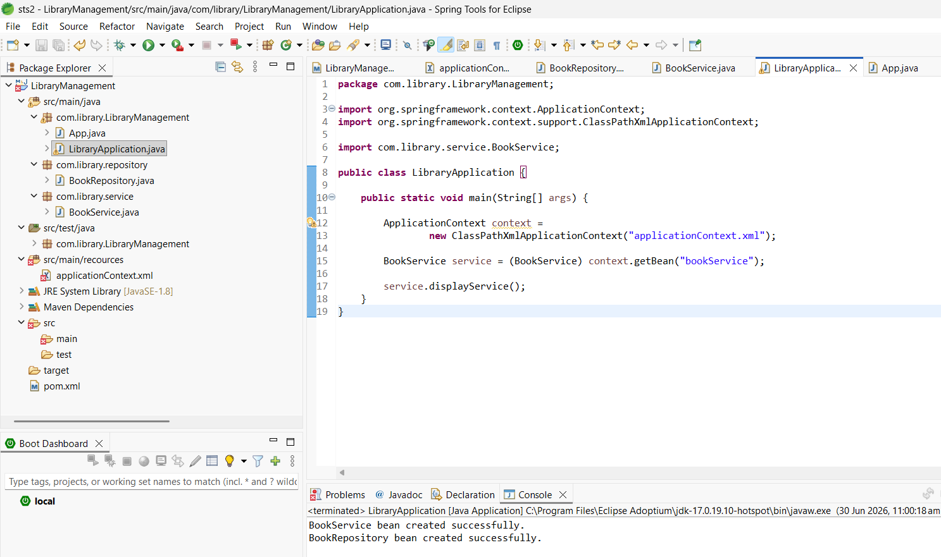

Exercise 4:
Creating and Configuring a Maven Project
Filename: pom.xml
<project xmlns="http://maven.apache.org/POM/4.0.0"
xmlns:xsi="http://www.w3.org/2001/XMLSchema-instance"
xsi:schemaLocation="http://maven.apache.org/POM/4.0.0
http://maven.apache.org/xsd/maven-4.0.0.xsd">

<modelVersion>4.0.0</modelVersion>

<groupId>com.library</groupId>
<artifactId>LibraryManagement4</artifactId>
<version>0.0.1-SNAPSHOT</version>
<packaging>jar</packaging>

<name>LibraryManagement4</name>

<properties>
<project.build.sourceEncoding>UTF-8</project.build.sourceEncoding>
<maven.compiler.source>1.8</maven.compiler.source>
<maven.compiler.target>1.8</maven.compiler.target>
</properties>

<dependencies>

<!-- Spring Context -->
<dependency>
<groupId>org.springframework</groupId>
<artifactId>spring-context</artifactId>
<version>5.3.39</version>
</dependency>

<!-- Spring AOP -->
<dependency>
<groupId>org.springframework</groupId>
<artifactId>spring-aop</artifactId>
<version>5.3.39</version>
</dependency>

<!-- Spring Web MVC -->
<dependency>
<groupId>org.springframework</groupId>
<artifactId>spring-webmvc</artifactId>
<version>5.3.39</version>
</dependency>

<!-- JUnit -->
<dependency>
<groupId>junit</groupId>
<artifactId>junit</artifactId>
<version>3.8.1</version>
<scope>test</scope>
</dependency>

</dependencies>

<build>
<plugins>

<plugin>
<groupId>org.apache.maven.plugins</groupId>
<artifactId>maven-compiler-plugin</artifactId>
<version>3.11.0</version>

<configuration>
<source>1.8</source>
<target>1.8</target>
</configuration>

</plugin>

</plugins>
</build>

</project>

Output :
